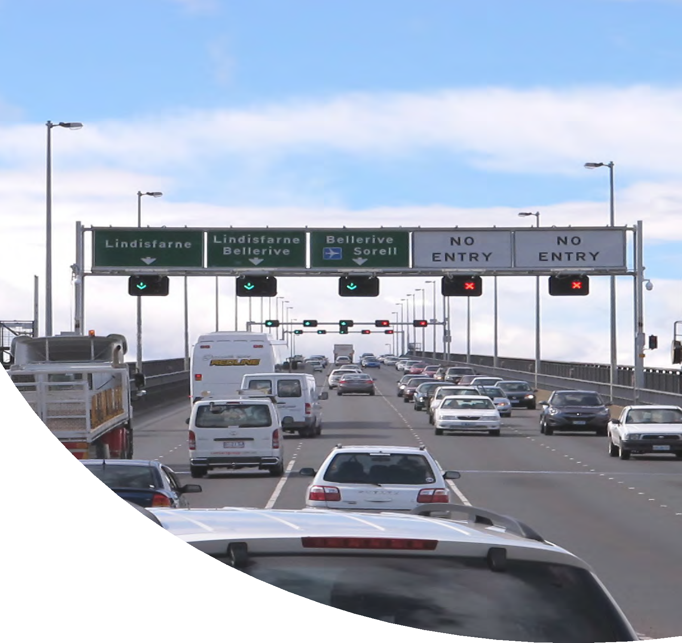

Towards Zero
– Tasmanian Road Safety Strategy 2017-2026 Discussion Paper

www.towardszero.tas.gov.au

Contents

Foreword 4
- Developing the Towards Zero – Tasmanian Road Safety Strategy 2017-2026 6
- Overview of the current Tasmanian Road Safety Strategy 2007-2016 8
- The Safe System Approach 12
- Community and Stakeholder Consultation – Tasmanians have their say 17
- Independent Crash Research – What the experts tell us 23
  - Safe Road Users 26
  - Safe Roads and Roadsides 31
  - Safe Speeds 36
  - Safe Vehicles 40
- Summary of CASR Research Findings 44
- Next Steps 50
Glossary of Terms 51

Foreword

Road safety affects us all.
Whether it’s the shock of a near miss, a small prang, sustaining a serious injury or losing someone we love, everybody is likely to be affected by road safety at some point in their life.
Over the past ten years, almost 3,500 people have been killed or seriously injured on Tasmanian roads. This is totally unacceptable – every life is precious and we must do everything we can to minimise the risk of using our road system.
People may find it easier to talk about road safety in an impersonal way by referring to statistics, trends and the road toll. This makes road trauma easier for us to accept – even the word ‘toll’ implies that it’s a price we are willing to pay. But road safety is so much more than just a number – imagine the grief of losing a child, or sustaining an injury and being unable to play your favourite sport or provide for your family. Not only are the outcomes devastating, but they can also have a lasting impact on those involved – emotionally and financially.
To reduce the level of road trauma in Tasmania, the Road Safety Advisory Council (RSAC) is developing the
Towards Zero – Tasmanian Road Safety Strategy 2017-2026.
The role of RSAC is to oversee the promotion and delivery of road safety initiatives in Tasmania and make recommendations to government about road safety policy. The Towards Zero Strategy will continue to be based on the ‘Safe System’ approach to road safety, which involves four essential elements working together to benefit road users – safe road user behaviour, safe roads and roadsides, safe vehicles and safe travel speeds. The Safe System recognises that people make mistakes and considers how we can make the whole system more forgiving, so that these mistakes don’t cost lives.
The purpose of this Discussion Paper is to put forward options for inclusion in the Towards Zero Strategy. These options are based on community views, lessons learned from our current strategy and independent research.

To ensure the success of the Towards Zero Strategy, we need your help.
Road safety is everyone’s responsibility and your input into the Strategy will be crucial. Let us create the safest road system we can – one that forgives our mistakes and works “towards zero” deaths and serious injuries on Tasmanian roads.

Jim Cox
Chair, Road Safety Advisory Council

4

5

How can you help?

Read this document

Reflect on what you have read and what the information means to you.

Go to www.towardszero.tas.gov.au and provide your comments through our

online feedback form by 31 May 2016.

- Developing the Towards Zero
– Tasmanian Road Safety Strategy 2017-2026

The current Tasmanian Road Safety Strategy 2007-2016 is nearing the end of its life.
Over the past ten years nearly 3,500 people have been killed or seriously injured on Tasmanian roads. This is totally unacceptable – although mistakes and crashes are inevitable, death and serious injury are not.
The Towards Zero Strategy will set the direction for road safety in Tasmania over the next ten years, with the long-term vision of zero deaths and serious injuries on our roads.

What will inform the Towards Zero Strategy?
The Towards Zero Strategy will be informed by research and best practice advice, which has been provided by road safety experts from the Centre of Automotive Safety Research (CASR) at the University of Adelaide.
The Strategy must also take into account the attitudes and viewpoints of community members and key stakeholders. With this in mind, RSAC undertook an extensive consultation process to ensure that community members and key stakeholders had the opportunity for input right from the very start.

What are the next steps?
This Discussion Paper is not the Towards Zero Strategy – it is a summary of findings from community and stakeholder consultation, and the expert recommendations made by CASR.
Before RSAC finalises the Strategy and makes recommendations to Government, we are seeking your views on our findings, and what we propose.
Over the life of the Towards Zero Strategy (from 2017- 2026), action plans will be developed to identify which practical actions will be implemented and the timeframes needed to achieve serious casualty reductions and address problem areas.

Our goal
The long-term vision of the Towards Zero Strategy is to achieve zero deaths and serious injuries on Tasmania’s roads.

6

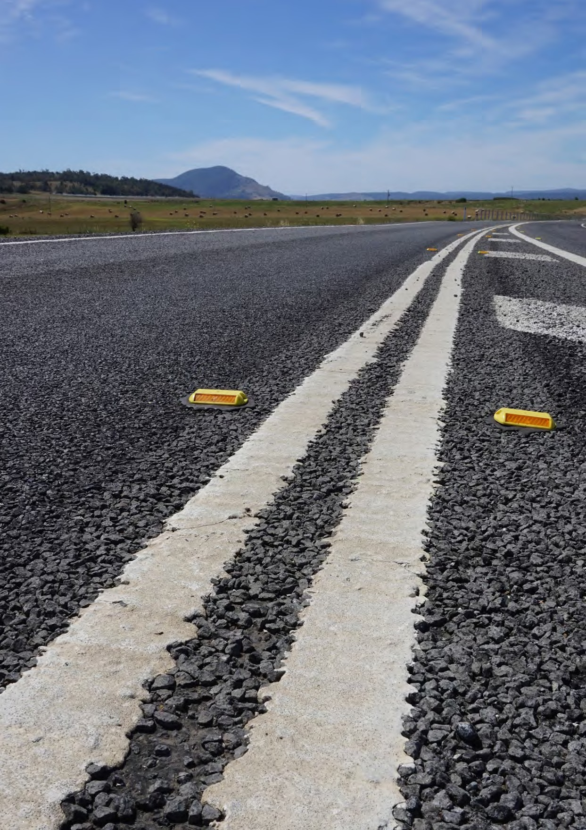

7

- Overview of the current
Tasmanian Road Safety Strategy 2007-2016

The Tasmanian Road Safety Strategy 2007-2016 has focused on reducing serious casualties (see page 51, Glossary of Terms), and has achieved a steady reduction.
However, to achieve our long-term goal of zero deaths and serious injuries on our roads, we need to build on our achievements and continue to address areas which have high priority.

What have we done over the last 10 years?
Over the last 10 years we have introduced a range of measures to help reduce serious casualties on our roads. Following are just a few examples of the types of measures we have introduced.
To encourage safer travel speeds, we now have electronic speed limit signs at schools, variable speed limit signs on the Tasman Highway, changing road conditions signage on roads with a rural default speed limit of 100km/h and fixed speed cameras at seven locations. Speed limits on gravel roads have also reduced from 100km/h to 80 km/h.
Around three quarters of road safety funding has been used to install best practice infrastructure. This includes 2+1 road design (see glossary) at Symmons Plains on the Midland Highway and Gannons Hill on the Bass Highway, median flexible safety barriers, edge barriers, shoulder widening and audible edge and centrelines. It also includes motorcycle safety treatments such as stack cushions, collapsible chevron alignment markers, rub rail and wet and icy traffic systems. Cycling warning signage on popular cycling routes and a Vulnerable Road User Program to minimise conflict between vehicles and pedestrians, cyclists and motorcyclists, are also initiatives which have been introduced.
To enhance vehicle safety we have supported the Australasian New Car Assessment Program (ANCAP), introduced a minimum five-star safety rating for the Government car fleet, developed the ‘How safe is your car’ campaign to encourage Tasmanians to buy the safest car they can afford and we’ve promoted how to maintain your car to make it safer.
Many campaigns have also been launched to encourage road users to be safer on our roads. These include a campaign to encourage drivers to leave a minimum passing distance when passing cyclists, a tourist strategy to raise awareness of international visitors and interstate motorcyclists, and a ‘share the road’ campaign for all road users.
In addition to campaigns, we have also encouraged road users to be safer through the introduction of alcohol interlocks for repeat and high level drink driving offences, by reviewing the graduated licensing system, and
by changing the law to allow motorists to cross a centreline to pass cyclists safely. We have also developed a Community Road Safety Grants Program to support communities to address local road safety issues at the grass roots level.

8

Funding road safety initiatives
Road safety initiatives in Tasmania are largely funded by the Road Safety Levy. The Road Safety Levy was introduced in 2007 to fund the Tasmanian Road Safety Strategy 2007-2016. A levy of $25 per annum (concession
$15) is payable on the registration of all vehicles that have broad access to the road network. This raises around
$12.6 million per year. The RSAC oversees the expenditure of the Levy. The Levy is crucial to the delivery of initiatives developed in accordance with the Strategy and its action plans. New road safety measures must be considered and prioritised within the context of available funding.

What results have we seen?
For the 10 year period 1995 to 2004, just over 5,000 people were seriously injured or killed on Tasmanian roads. For the period 2005 to 2014, coinciding with the introduction of the Tasmanian Road Safety Strategy 2007-2016, there were almost 3,500 deaths and serious injuries on Tasmanian roads.
In the current Strategy, a target was set which would see serious casualties almost halved between 2005 and 2020.
As can be seen from the graph below, looking at the 15 year period from 2001 to 2015, reductions in serious casualties are starting to plateau. Although our road trauma level has been decreasing, it is highly unlikely that our ambitious target will be achieved if we don’t implement new measures.

Tasmanian Serious Casualties (5 year averages)

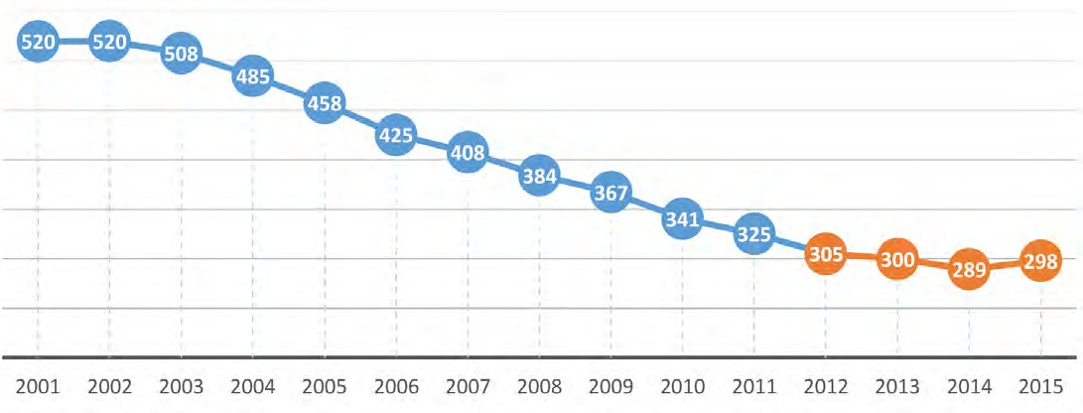

9

Serious casualty statistics at a glance 2001-2014
Annual average number of fatal and serious casualties for various target areas during the three periods 2001- 2006, 2007-2010, and 2011-2014.

Target Area | Annual average in period
 | 2001-2006 | 2007-2010 | 2011-2014
All crashes | 442 | 332 | 290
Rural crashes | 260 | 216 | 181
High speed crashes (80 km/h and above) | 267 | 210 | 173
Night time crashes (8pm-6am) | 94 | 68 | 46
Run off road crashes (straight alignment) | 73 | 64 | 50
Run off road crashes (curved alignment) | 128 | 94 | 83
Crashes at intersections | 68 | 43 | 39
Hit fixed object crashes | 128 | 109 | 73
Head on crashes | 79 | 61 | 49
Crashes involving young drivers (<25 years old) | 132 | 86 | 57
Crashes involving novice drivers (L or P licence) | 79 | 65 | 41
Crashes involving older drivers (>65 years old) | 49 | 38 | 43
Crashes involving pedestrians | 44 | 30 | 33
Crashes involving pedal cycles | 14 | 10 | 12
Crashes involving motorcycles | 86 | 81 | 76
Crashes involving trucks | 39 | 29 | 19

10

As can be seen from the map below, most serious casualty crashes occurred around Tasmania’s larger cities, and on the highways that connect these metropolitan centres. However, as serious casualties occur across the whole network, we need to implement countermeasures that will address issues State-wide.

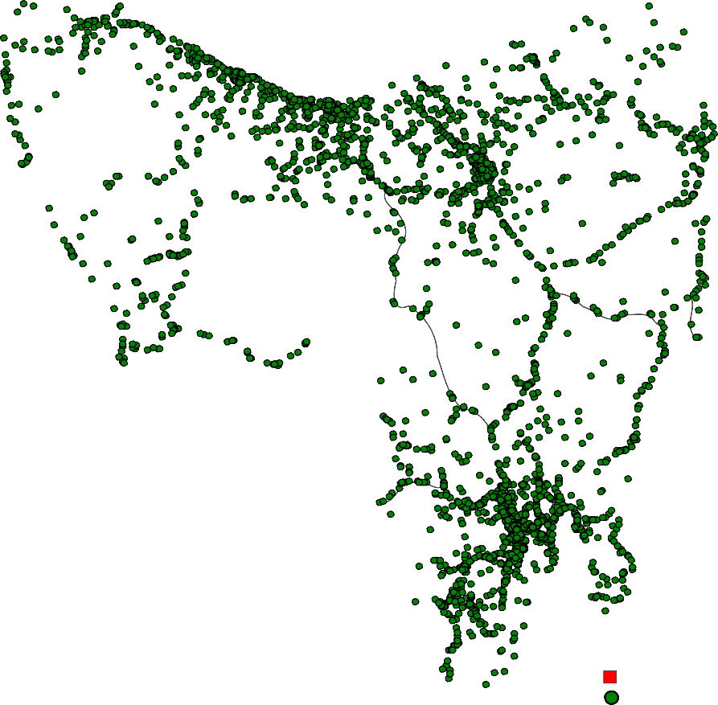

Map 1 Serious casualties 2001-2014

Fatality Serious Injury

11

The Safe System Approach

The Towards Zero Strategy will be based on the ‘Safe System’ approach to road safety. The Safe System approach benefits all road users and is considered worldwide as best practice in road safety.
A Safe System has four essential elements:

- Safe Road Users – encouraging safe, compliant behaviour through education, enforcement and regulation.
- Safe Roads and Roadsides – designing and maintaining roads to reduce the risk and severity of crashes.
- Safe Speeds – setting appropriate speed limits that complement the road environment.
- Safe Vehicles – designing vehicles that protect occupants, lessen the likelihood of a crash and simplify the driving task.

To prevent death or serious injury on our roads, all four elements of the Safe System must work together and continue to be improved. If a crash occurs as a result of a specific weakness of one element, the other three elements should be strong enough to counteract the effects of the crash.
New road safety measures must be considered as part of a whole system to tackle a particular issue. For example, if we know that young drivers are overrepresented in crashes, we must look at ways to change their behaviour on the roads, how the roads might be improved to reduce the impact of them crashing, how speed management might improve their safety and how safer vehicles might better protect them.
The Safe System approach acknowledges that we are all human and we can all make mistakes on the road. Therefore, human frailty is placed at the centre of the System design, so that mistakes don’t result in serious injury or death.
Achieving our long term vision of zero deaths and serious injuries on Tasmania’s roads will not be easy, but we must work towards it. Responsibility for road safety is shared by everyone, with road users, road designers, vehicle manufacturers and policy makers all having a role to play.
If you haven’t yet seen our Safe System video, go to www.towardszero.tas.gov.au

12

Human
tolerance to crash impact
c
r
E
sh
s
v

Safe System Principles
- People make mistakes.
- People are fragile.
- We need to create a more forgiving road system.
- We need to share responsibility for road safety.

13

What does a Safe System look like?
A successful Safe System will protect people from crash forces if all four of its elements work together to forgive human error.

Safe Road Users
Everyone can make mistakes and get distracted while driving. Under a Safe System, road users must focus on following the road rules, driving to the conditions and being alert and attentive.

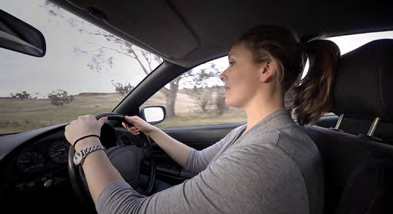
Distracted driver Driver focused on driving task

Safe Roads and Roadsides
Road infrastructure plays a vital role in helping to reduce crashes and minimises the extent of injury in the event of a crash.
In the example provided, the road has a loose gravel shoulder rather than being paved, which is less safe in the event that a vehicle veers from the road. Treatments to address this include sealing the shoulder making it easier to stop and/or steer back onto the road. Audio tactile line markings could also be installed – these produce noise and vibration when struck by car tyres which alerts the driver they are leaving the road, generally due to distraction or drowsiness.

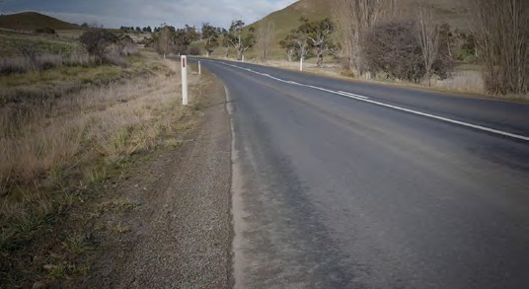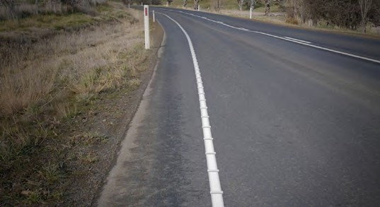
Unsealed road shoulder Sealed shoulder provided with audio tactile edge line

14

Safe Speeds
Under a Safe System, speed limits are set at survivable levels that are appropriate for the road type. Road users will also travel at speeds that are suitable for the conditions.
If speed limits are set appropriately and road users travel at speeds appropriate for the conditions, the effectiveness of road infrastructure and vehicle safety initiatives are enhanced.
Under a Safe System, if a road does not have safety features, the speed limit should be lower. Speed management has an important place in improving the risk profile of our infrastructure where roads cannot be upgraded due to physical constraints, or as an interim measure until infrastructure treatments can be undertaken.

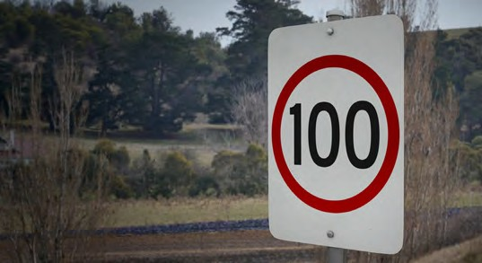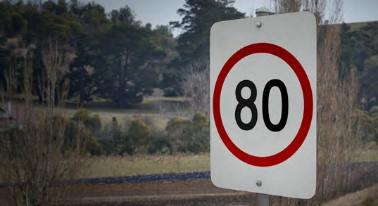
Higher travel speeds Lower, more appropriate travel speeds

Safe Vehicles
Vehicles that are designed well for safety can either prevent a crash from happening or help absorb the energy in the event of a crash. Under a Safe System, everyone will be encouraged to drive the safest vehicle they can afford. Ideally, this will be a five star safety rated vehicle.
The first vehicle shown is a car with a three star safety rating. In the frontal offset collision test (conducted at 64km/h) the passenger compartment has started to collapse and the dashboard has been forced into the
passenger space putting occupants at risk of severe chest and leg injuries. The test also showed that there would be a high risk of life-threatening chest injuries to vehicle occupants in a side impact. This vehicle also does not have electronic stability control (ESC).
Compare this to a five star car in the same tests. In the frontal offset collision (again conducted at 64km/h) the passenger compartment held its shape well and dashboard displacement was well controlled. Side impact testing showed that the vehicle provided adequate chest protection. ESC comes as standard in this vehicle.

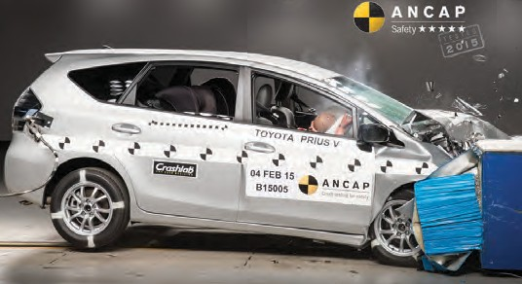
3 star safety rated vehicle 5 star safety rated vehicle

15

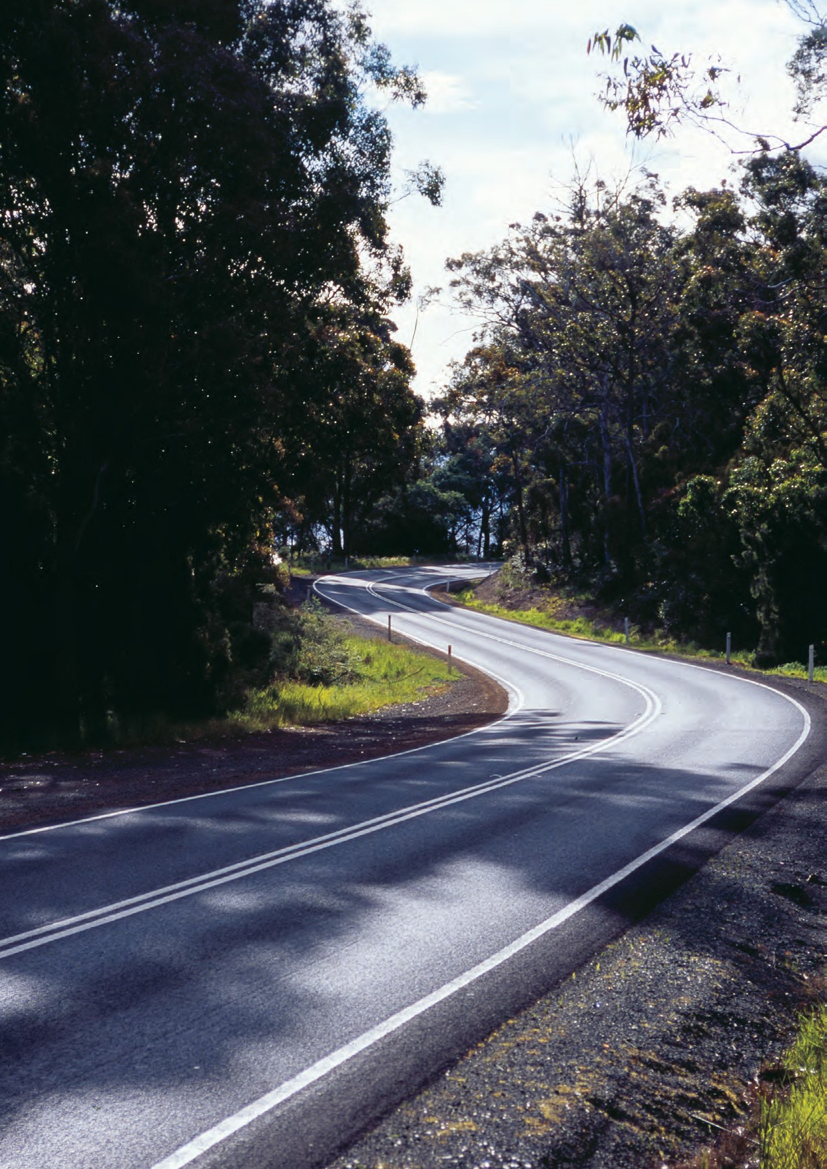

16

Community and Stakeholder Consultation – Tasmanians have their say

Why are community and stakeholder views important?
Effective community and stakeholder consultation is critical in the development of the Towards Zero Strategy. Without strong community and stakeholder support, our vision of zero deaths and serious injuries cannot be achieved.
We are all road users and all have our part to play in achieving a Safe System. Therefore, for the Strategy to be successful, it is important that we listen to community and stakeholder views on how road safety can be improved in Tasmania and value those perspectives.

So far around 650 people have joined the conversation.
Forums were held through October-December 2015 for community members, external stakeholders and state government stakeholders. The aim of the forums was to provide information about the development of the Strategy, explain the road safety problem, and give participants an opportunity to put forward their ideas.
An online survey was also developed, and written submissions welcomed.
The comments we heard were diverse and insightful, offering numerous (and differing) suggestions on road safety improvements.
This is where research can help guide us – by sharing what we know through crash data analysis and modelling and comparing this to community and stakeholder views, we can begin to identify solutions that are evidence based and have community support.

“The public forum presented some very interesting and thought-
provoking information. I look forward to continuing to be part of the process throughout 2016.”
Community Forum Participant, Burnie

17

How did we gather comments?

Community forums
hearing community concerns
We went to five key regions across Tasmania to find out first-hand what the communities’ views were and why. Around 70 people participated in these forums, with the discussion being diverse and thought-provoking. Forums were held in the following locations:
- South (Hobart)
- West (Queenstown)
- North-West (Burnie)
- North (Launceston)
- East (St Helens)
State Government stakeholder forums
an internal perspective
We met with around 125 government stakeholders and Members of Parliament to gather their views from an internal working perspective.
This included representatives from Police, Ambulance Tasmania, and the Transport Services Division of the Department of State Growth.
Each group had their own specific road safety concerns which were unique to their particular area of work.
Written submissions
research and additional comments
In addition to the forums and survey, community members and stakeholders were invited to make a written submission.
A total of 17 submissions were received, many of which were thoroughly researched and highly detailed.

18

Online survey
getting input online
Not everyone was able to attend a forum, so we created a survey which could be completed online. 370 people responded to the survey over a period of 11 weeks.
Respondents had a lot to say about road safety, with most people taking the opportunity to provide additional detailed comments where possible.
External stakeholder forums
local government, industry, special interest groups
We met with around 60 key stakeholders to gather a more varied road safety perspective. These stakeholders were from diverse groups who had varying priorities in terms of key challenges and how they could be addressed. Participants included:
- Motoring organisations
- Bicycle user groups
- Motorcycle associations
- Local government
- Public transport associations
- Driver training associations
- Road trauma support services
- Road accident insurers
- Child safety associations

What did we hear?
We asked for community and stakeholder views on numerous road safety issues. As a result, we heard various concerns, opinions and suggestions for improvement. The full report detailing the results from consultation can be found at www.towardszero.tas.gov.au.

19

Key messages from online survey

Can you make a difference to road safety? If so, how?  63% of respondents believed that they could do something to make a difference to road safety.  The majority said that improving their decision making, being more courteous and encouraging others to do the same could help to make our roads safer. | Do you agree with the Safe System principles? What is the biggest threat to achieving a Safe System?  The large majority of respondents agreed with the Safe System principles, and believed that driver behaviour and driving at excessive speeds for the conditions were factors which could cause a problem within the System. | What is the biggest thing that can be done to improve road safety?  The majority of respondents believed that focusing on education and driver training is critical to improving road safety.  Increased police presence on our roads and better road maintenance were also frequent responses.

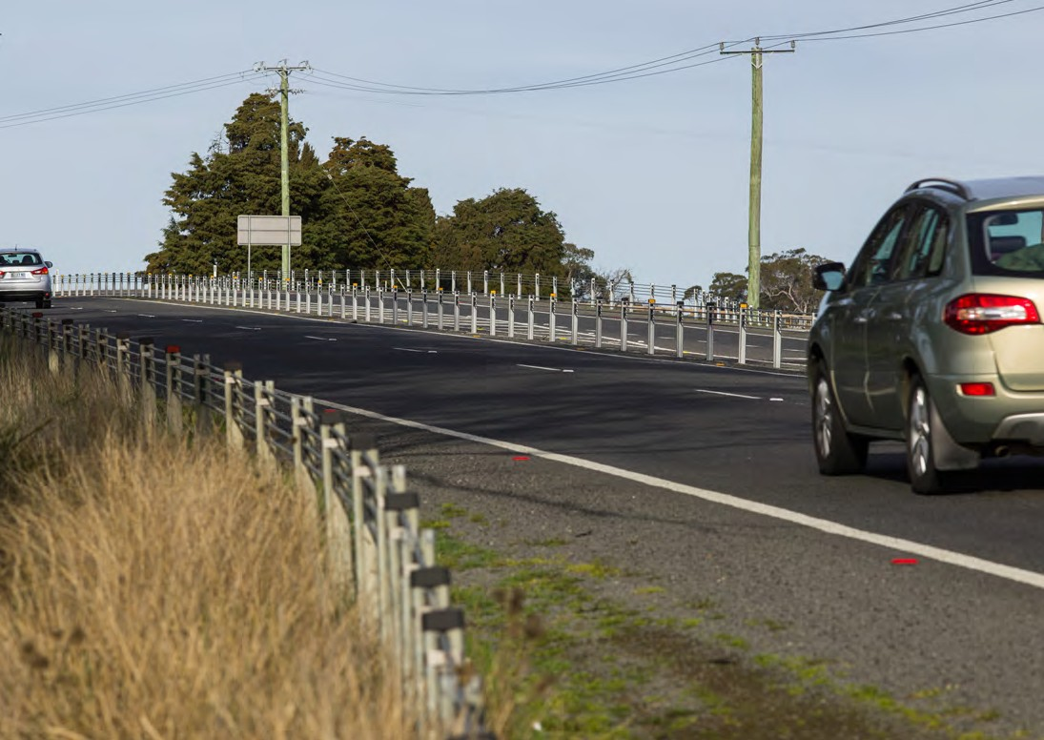20

Key observations from consultation
The table below shows the most frequent comments from the consultation process and where they fit within the Safe System framework. Each element of the Safe System will be discussed separately in this paper.

Safe Road Users | Safe Roads/ Roadsides | Safe Speeds | Safe Vehicles
Improve driver attitudes (courtesy, attention)  Improve driver training More police  Drive to conditions education  Road rules education (intersections; roundabouts; merging; tailgating; regular updates of changes)  Ongoing driver training and assessment  Increase penalties  Primary/high school education | More consideration of cyclists/pedestrians in road design  Better maintenance Better signage  More pull over bays/ overtaking lanes  Remove overgrown vegetation on roadsides  Wire rope barriers  Separation of traffic at high speeds | More police Reduce speed limits  More speed cameras (fixed and moving)  Increase speed penalties  No penalties for minor breaches  Fewer speed zones/ changes  Uniform, sensible speed limits | Block mobile phone signals  Periodic vehicle inspections  Speed limiters Alcohol interlocks  Less distracting in-car technology  Novice power restrictions  Incentives to drive safer vehicles  Ban vehicle modifications

21

How will we use these comments?
From consultation, it is clear that many Tasmanians are concerned about the need to improve driver behaviour and bad attitudes on our roads. We recognise that road user behaviour is crucial, and that it is important to continue to improve driver attitudes and reinforce education on road rules and the significance of driving to the conditions.
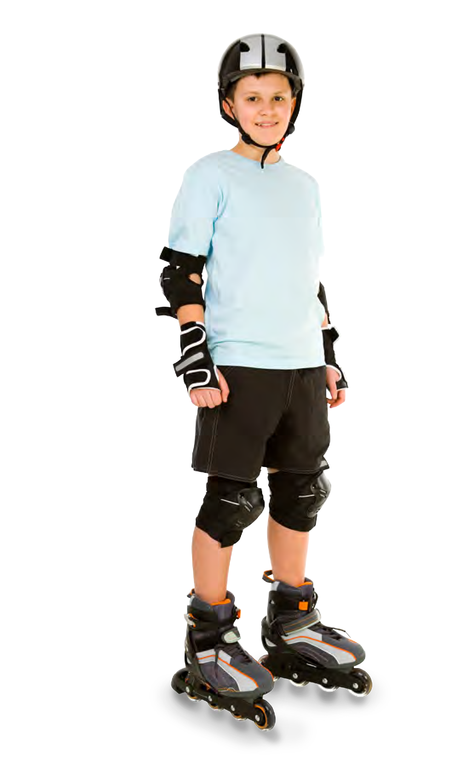Road user behaviour is central to the ‘Safe Road Users’ part of the Safe System. We will continue to work towards improving driver behaviour, but we must also acknowledge that even if we all obeyed the rules all of the time, we would still make mistakes, leading to crashes. We therefore need to also think about how we can improve the other parts of the road system – speed, roads and vehicles – to ensure that if a crash does occur, the chance of serious injury and death is eliminated.
So how do we do this? To help us find the answers, we have looked to the research
for guidance.
Myth: Allowing for mistakes means drivers are let off
the hook.
This is not the case….
A Safe System critically depends on road users obeying the rules and being alert. Road safety education, training and enforcement remain very important.
22

- Independent Crash Research
– What the experts tell us

To assist in the development of the Towards Zero Strategy, the Centre of Automotive Safety Research (CASR) at the University of Adelaide has taken an in-depth look at Tasmania’s crash statistics, undertaken extensive research and provided advice on best practice initiatives for Tasmania.

Who is CASR?
CASR is an internationally recognised, leading research organisation that has been at the forefront of road safety analysis for over 30 years. The Centre provides professional advice to various organisations worldwide, and focuses on conducting high quality, independent crash research to enable organisations to make well-informed decisions to reduce road trauma. For more information, visit http://casr.adelaide.edu.au/.

How will the research help us?
CASR’s research identified, described and recommended proven safety measures to help us save lives and prevent serious casualties on our roads. This will help us to understand the evidence and make informed choices about which safety measures to put into action.

How did CASR approach the research?
CASR approached the research in four steps:
Firstly, CASR gathered data on our crash statistics, road environment, treatment costs, our commitment to invest and many other factors that will have an effect on the new Strategy.
Secondly, CASR reviewed the performance of the Tasmanian Road Safety Strategy 2007-2016 to determine what measures were successful and priorities for improvement.
Thirdly, CASR developed a method for modelling fatal and serious road injuries in Tasmania. This modelling involved using road transport data (including crash data, traffic growth and the impact of previous road safety changes) from past years to predict the number of serious casualties in future years. The effects of possible future changes were also modelled to determine their possible effect on the number of serious casualties.
Forecasting future road trauma is a challenge, but by using a proven model we can reduce the potential for error as far as possible.
Lastly, CASR identified and discussed a range of potential countermeasures which could decrease serious casualties and move Tasmania’s road network further towards Safe System performance. Targets for the new Strategy were proposed and best-practice options recommended.

23

What did the research say?
The team at CASR has undertaken extensive research on Tasmania’s road environment and provided us with specific, best practice initiatives for each element of the Safe System. This combination of initiatives is considered by CASR as the best return on investment, with the ability to save the most lives and serious injuries on our roads. CASR has also identified how many serious casualties may be risked if we delay implementation or decide to go down a different path.
CASR’s full report can be viewed at www.towardszero.tas.gov.au.

We want to hear from you.
The next section outlines each of the four elements of the Safe System – it includes what we heard from the community and stakeholders, what the experts tell us, and what our options are.
This is where we need your help. We want the community to understand and engage with the Strategy to ensure we can continue to work towards meeting our goal of zero deaths and serious injuries on Tasmania’s roads. That’s why we have developed an online feedback form for you to complete once you have read and considered the options for each Safe System element.
All comments and possible measures will continue to be considered to ensure we have a robust and sustainable road safety strategy for the next ten years.
The online feedback form is available at www.towardszero.tas.gov.au
– please have your say!

Myth: It’s mostly the young, inexperienced drivers that we have to worry about.
While it’s true that young drivers are over-represented in crash statistics, almost half of serious casualty crashes involve a driver aged 35 or over.

24

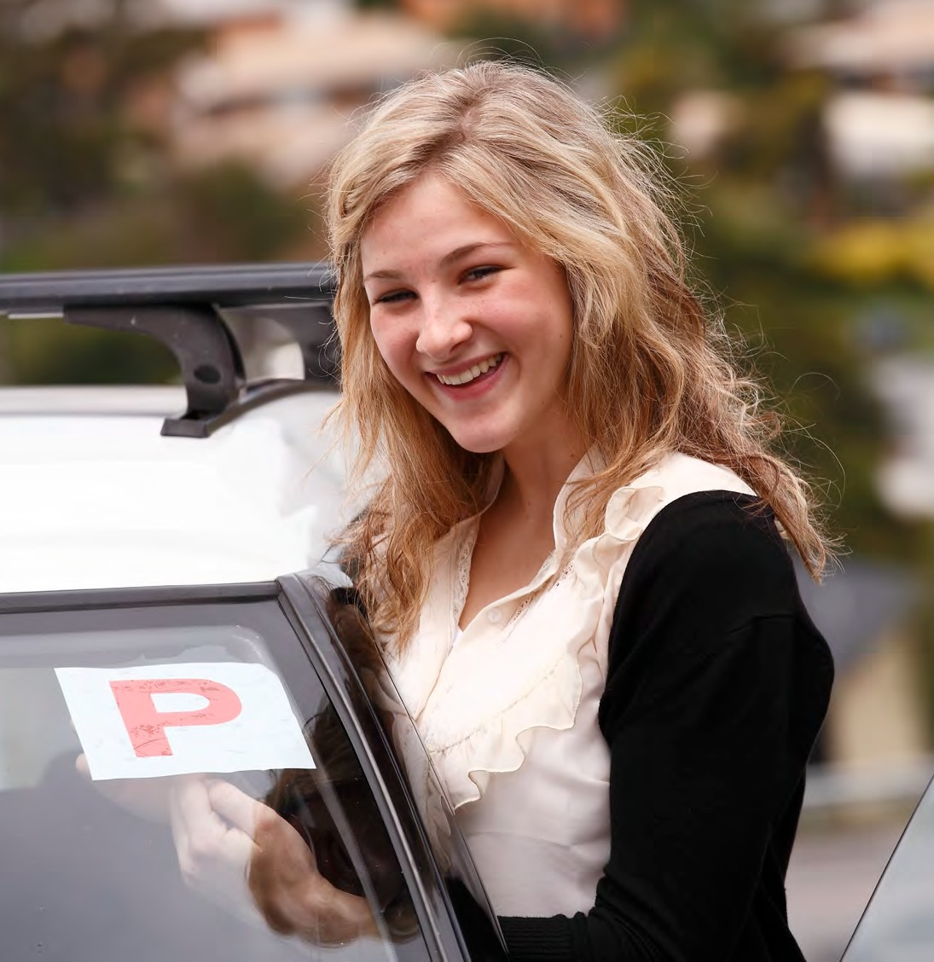

Tasmania’s crash data shows that the following are priority areas we need to address:

- Run-off road crashes
- Head-on crashes
- Motorcyclists
- Novice drivers
- Excessive speed
- Inattention and inexperience
- Cyclists
- Drink driving
- Pedestrians
- Older drivers

25

Safe Road Users

What did we hear from the community and stakeholders?

    - Most survey respondents believed it unlikely they would be caught if they broke a road rule, but were concerned with the penalties of doing so.
    - Most survey respondents told us that they never use their mobile phone whilst driving and, if they did, they used a hands-free device.
    - Improving driver attitudes, driver training, road rules education and road safety education in schools were common issues raised in consultation.

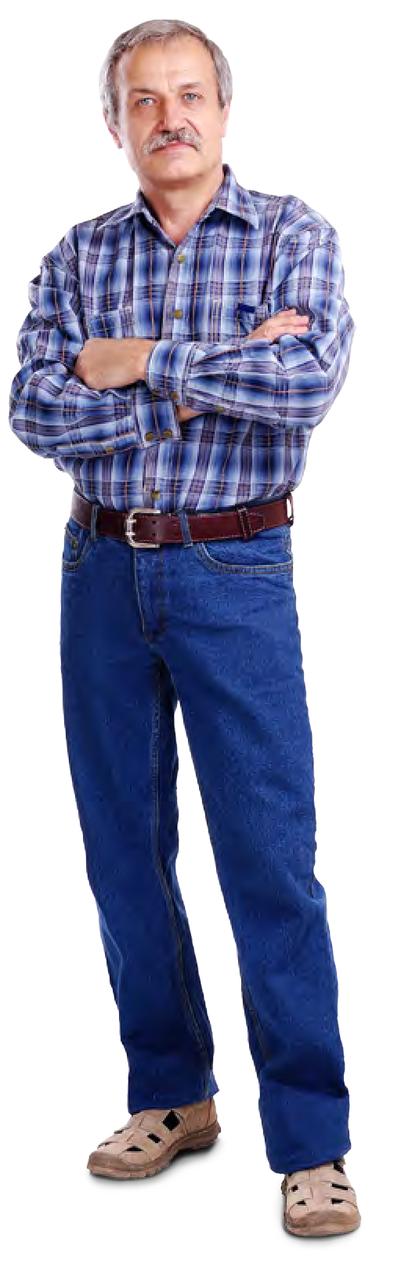Australia has been one of the most successful countries in achieving crash reductions from driver education. Education works best when integrated with regulation and enforcement. Educating people on appropriate driver behaviours such as road rules, courtesy and driving to the conditions is important, with various campaigns being implemented in the last ten years to address these issues. However, we must also remember that no matter how well trained and educated people are, mistakes and crashes will still continue to occur. Educating road users definitely has its benefits, but we need to realise that additional effective solutions could lie within other areas of the Safe System.

Myth: Road crashes will only decrease if we improve driver training and retest drivers regularly.
Not the only answer…
Improving driver skills does not always lead to a change in driver behaviour. In fact, research shows that driver training only plays a small role in reducing crash risk for drivers of all ages and experience, as even the most well- trained driver can still make a mistake.

26

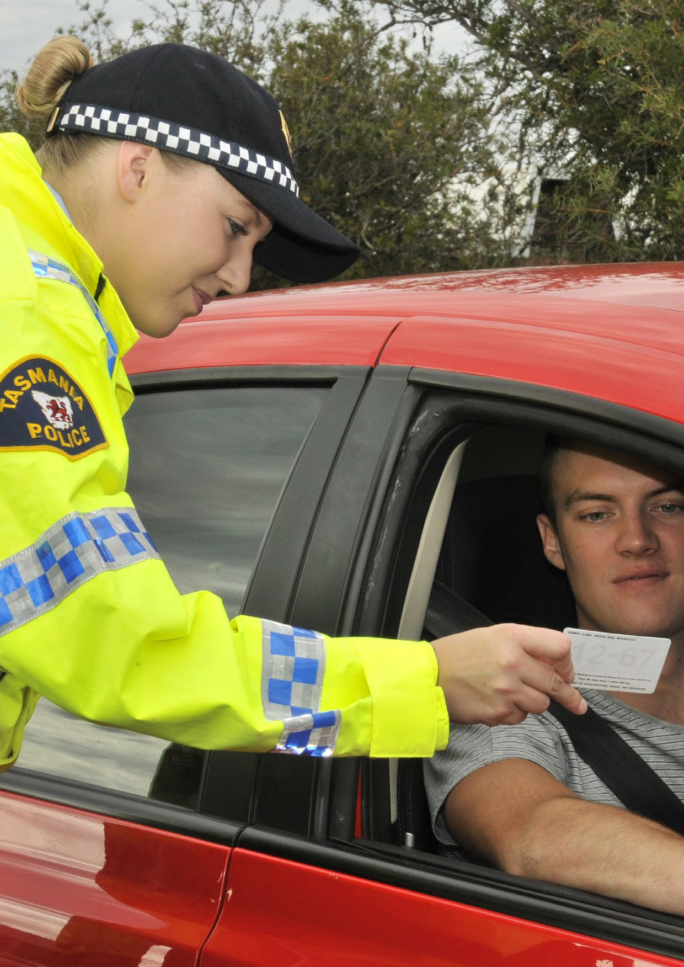

27

Community perception

“… It doesn’t matter what the speed limit is, or how good our roads and vehicles are – the real problem are drivers who have not been taught properly,

with bad attitudes …”

Research findings

Although people believe that “bad” drivers are the problem, extreme behaviours only explain a limited amount of the circumstances behind death and injury on the road. Even if all road users complied with the road rules all of the time, fatalities would only

fall by around 50% and injuries by 30%.

What do the experts think we should prioritise?

Continue with the current level of driver education and enhance the Graduated Licensing System (GLS)

55 1 fewer people killed or seriously injured
on our roads.
The current level of road user education and enforcement on our roads should continue in order to prevent regression in road safety performance. However, we need to have realistic expectations on what can be achieved through behavioural approaches when compared to other options.
A well designed GLS has been proven to be a highly successful approach in achieving safer road use. The GLS governs how novice drivers will progress from a learner through to a fully licensed driver, with rules and restrictions in place to enhance road safety.
Significant casualty reductions can be achieved over the next ten years if we make certain changes to our current GLS to reduce risk, for
example, increasing the age at which a driver can attain their P1 licence, introducing passenger restrictions and introducing a late-night curfew. These changes would assist novice drivers with concentration levels, but still allow experience to be developed in a safe environment. Impacts of these measures on employment and mobility will need to be taken into consideration.

What are the other options to make road users safe?

Increase driver education
To improve the safety of road users we could make more information available about misunderstood road rules and driver attitudes, as well as improve education for tourists and school children. Programs supporting safer road use can be effective 2 , however, researchers have generally struggled to demonstrate the effectiveness of these programs. It must therefore be acknowledged that other approaches under the Safe System may be more beneficial and cost-effective.

- This figure is an estimated reduction if GLS changes are implemented in 2017 and includes the effects of other intangibles. It is based on a compliance rate of 80%, assuming that some novice drivers may not comply with restrictions or have a work exemption.

- Highly successful initiatives in Tasmania which have improved road user behaviour include the adoption of Graduated Licensing Systems, greater speed enforcement with mass media coverage and random breath testing.

28

Increase the enforcement level on our roads
Studies have shown that more speed cameras and increased, well-managed police enforcement can improve compliance with road rules and result in crash reductions of around 30%. However, police resources are limited and cover a wide range of activities. To increase effectiveness, enforcement should also be backed up with mass media campaigns.

Lower Blood Alcohol Content (BAC)
Studies have shown that any decrease in the legal BAC limit is associated with significant crash reductions. Currently, even a BAC below the legal limit (0.05) can impair a driver’s decision making and reaction time. Decreasing the current legal BAC level to 0.02 may be an option to consider.

Promote protective clothing for motorcyclists
Motorcyclists are a specific road user group that are more at risk of injury in the event of a crash. Studies have shown that wearing protective motorcycle jackets and pants can reduce the likelihood of a motorcyclist
being admitted to hospital by around 50%. Promotion of the wearing of protective clothing has clear benefit in reducing injuries for motorcyclists.

What do you think we should do?

Complete the online questionnaire to provide your feedback.

29

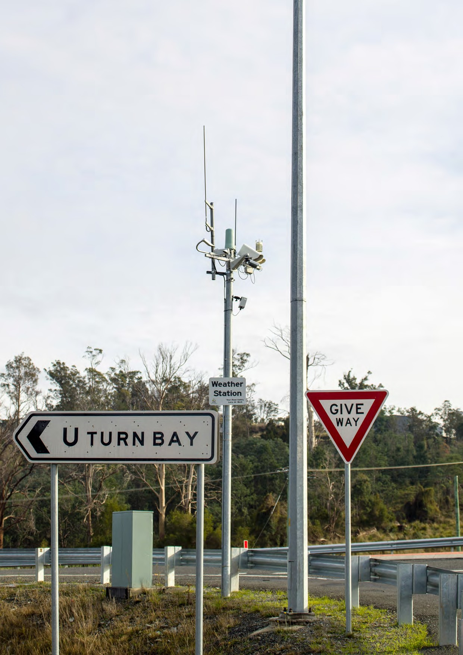

30

Community perception

“… Money would be better spent on teaching people not to crash, rather than giving them something soft to crash into …”

Research findings

No matter how well-trained road users are, mistakes will still

occur. Safer infrastructure is capable of providing an environment which is

forgiving of human error, should a driver make a mistake. If we make the suggested investment in infrastructure, Tasmania is likely to see a much higher reduction

in road trauma than would be the result of investment

into improving driver behaviour.

Safe Roads and Roadsides

What did we hear from the community and stakeholders?
    - Most survey respondents felt that Tasmania’s roads are ‘somewhat’ safe, with divided highways being the safest, and gravel roads the most dangerous.
    - Many people believe that our roads and roadsides need to be better maintained.
    - Many people, namely cyclists, pedestrians and motorcyclists, believe there needs to be more consideration of ALL road users in road design.
    - Many people believe that more overtaking lanes and pull-over bays on high volume roads would decrease frustration.

We all deserve to drive on safe roads, and to know that if we do crash, we can expect the best outcome. Many people feel that Tasmania’s roads and roadsides can be improved to maximise safety, whether it be by increasing maintenance, creating more pull-over bays or improving infrastructure for cyclists. On the other hand, some community members believe that our roads are safe enough, and money would
be better spent elsewhere – but research from around the world has shown that reductions in road trauma can be largely attributed to investment in safer roads and roadsides.

Myth: We already have safe roads.

Tasmania has a large road network – more than 18,000 kilometres of State-owned and local roads cover a wide geographical area. As many of these roads were built more than a hundred years ago, our roads can be safer. Road standards change over time, so we must continue to install safety treatments that are proven to reduce the likelihood and severity of crashes.

31

What do the experts think we should prioritise?

Target run-off road, head-on and intersection crashes

High reductions in fatal and serious crashes expected if appropriate infrastructure treatments
are implemented.

CASR recommended that if funding were available, 2+1 and 2+2 road configurations with centreline barriers would be the most preferable treatment to reduce run-off road and head-on
crashes. We are progressively rolling out such treatments on our high volume, higher risk routes.
While 2+1 configuration roads would have the highest safety return, they are also the most expensive treatment considered. The creation of a safe road environment using barriers in the centre of the road and on the roadsides in a 2+1 configuration will cost around $730 million on trunk roads alone. It is evident that achieving a Safe System compliant network using 2+1 roads is cost prohibitive. But we can implement a program that
prioritises installation of such treatments on higher risk roads, as funds permit.
In relation to intersection crashes, CASR acknowledge that grade separation represents the most effective way of eliminating this type of crash, but it is expensive. Upgrading of intersections by installing roundabouts on trunk roads where injury crashes have occurred, would cost in the order of $2.1 billion. The cost of applying such an approach to all intersections across the network would be extremely cost prohibitive. Grade separation though could still be considered at intersections on strategically important high volume roads and high risk locations, as funds permit.
CASR recommended that other low cost measures should be considered, in terms of their potential to reduce overall death and injury. These include:
    - Audio tactile line markings (see glossary)
    - Centreline barriers
    - Wide centrelines (where centreline barriers are not feasible)
    - Sealed shoulders

At intersections, CASR also recommended that right turns should be eliminated where possible on the entire network. This would reduce the potential for high speed, right-angle crashes. If this is not viable, plateaus (raised platforms) should be utilised.

32

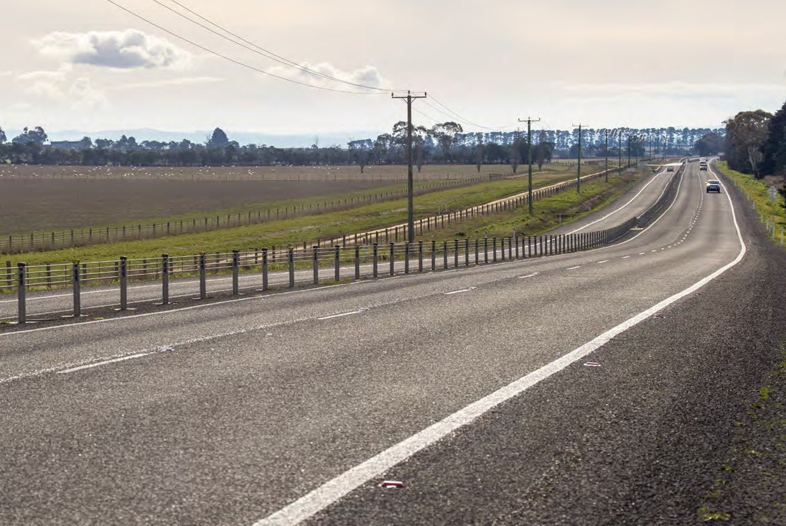

Midland Highway - Symmons Plains 2+1 Installation
Between 2005 and 2009, four people died, three were seriously injured and 14 suffered minor injuries on the Midland Highway, near Symmons Plains. The crashes involved out-of-control vehicles that crossed into the path of oncoming traffic.
Separating vehicles travelling in opposite directions has been highly successful in reducing head-on collisions. Research shows that flexible median barriers can reduce head-on crashes by up to 90%.
To address the crash problem on this 5km stretch of highway, a ‘2+1’ configuration road with median flexible safety barriers was installed. The cost of the project was $7.5 million, which was funded from the Tasmanian Road Safety Levy.
The works conducted at this site included widening the highway to allow for the installation of flexible safety barriers along the median strip, and incorporating a 2+1 road configuration. This provides two lanes in one direction and one lane in the opposite direction. This is alternated so vehicles travelling in either direction have overtaking opportunities.

33

Costs and benefits?
Accurately modelling the effects of introducing widespread, large scale infrastructure treatments is extremely difficult. Table 1 however summarises the potential benefits and costs of different infrastructure treatments. It also provides a guide as to where treatments might be applied on the network:

Countermeasure Expected Benefit

Expected Cost

Where

2+1 configuration $$$ Highest volume, strategically important roads

Centreline barrier $$$ Highest volume, trunk, freight and regional access routes
Highest volume, trunk, freight and regional

Wide centreline $$

Sealed shoulders $$

Audio tactile line marking $
access routes where centreline barrier not feasible
Highest volume, trunk, freight and regional access routes where above treatments not possible
Highest volume, trunk, freight and regional access routes where above treatments not possible

Grade separation* $$$ Highest volume, trunk, freight and regional access routes
Highest volume, trunk, freight and regional access routes

Roundabouts* $$
Discrete sites if warranted on lower order roads

No right turn* $ Where viable

Right turn lanes* $ Entire network

Plateaus* $
Highest volume, trunk, freight and regional access routes
Any road types in a built up area if warranted
* Intersection treatments

Table 1 Effectiveness and cost of Safe System infrastructure treatments in reducing
serious casualties in Tasmania and recommended locations for infrastructure treatments 3
3 Based on CASR modelling
34

What are the other options?

Develop more overtaking lanes
Despite an assumption that overtaking lanes improve safety, CASR noted there are very few studies that actually prove that this is the case. This suggests that the safety effect is likely to be influenced by many other factors.
Traditionally, overtaking lanes were implemented on the basis of traffic efficiency with safety as an assumed benefit. It is worthwhile noting that the greatest reductions in injury crashes were associated with the use of overtaking lanes with additional centreline treatments (either wide centrelines or centreline barriers).

Safety for cyclists
CASR also considered infrastructure measures to improve safety for cyclists and acknowledged the significant difficulties in such an approach. The task of retrofitting the road system to improve cyclist safety is difficult as the system is inherently unsafe for this group in most locations and there is community resistance to giving up car space for cyclists. From a theoretical perspective the solution is simple: where speeds cannot be managed to safe levels, segregation should occur. It may be easier to provide separate safe corridors as viable alternatives for cyclists to access different areas, particularly cities, backed up by appropriate infrastructure treatments.

Safety for pedestrians
CASR considered infrastructure measures to address pedestrian safety. Due to the highly random nature of pedestrian collisions in built up areas of Tasmania, an infrastructure response is difficult. However, CASR
suggested that it would be desirable to install raised platforms at dedicated pedestrian crossing facilities to slow down vehicles to safe speeds.

What do you think we should do?

Complete the online questionnaire to provide your feedback.

35

Safe Speeds

What did we hear from the community and stakeholders?
    - Most survey respondents felt that speed is a factor in causing crashes.
    - Many people believe that improved in-car speed technology and more speed cameras would help to reduce speeding.
    - The community were divided on the issue of whether speed limits should be reduced.

While most respondents believe that speed is a factor in causing crashes, there are concerns that there is too much emphasis on penalising speed and not enough on penalising bad behaviours. While bad behaviour should indeed be penalised, what must be acknowledged is that the higher the speed, the greater the chance of being in a crash and the more severe the consequences will be. Speed limits need to be set at appropriate levels and road users need to travel at speeds that are suitable for the conditions. At current travelling speeds, in many
cases, vehicles are unable to protect occupants and other road users when crashes occur.
Add to this the complexity of children, the elderly, motorcycles and heavy vehicles, and it becomes apparent that our speed limits are not always appropriate in a Safe System context.

Myth: Reducing speed limits won’t save lives, it will just take me longer to get anywhere.
Travelling time does not increase by the same proportion as a speed reduction. For example, reducing the speed limit by 10% does not result in a 10% increase in travel time. Research shows that the effect on travel time can actually be as low as 4% - this is a good compromise considering the number of lives and serious injuries which could be saved by driving that little bit slower.

36

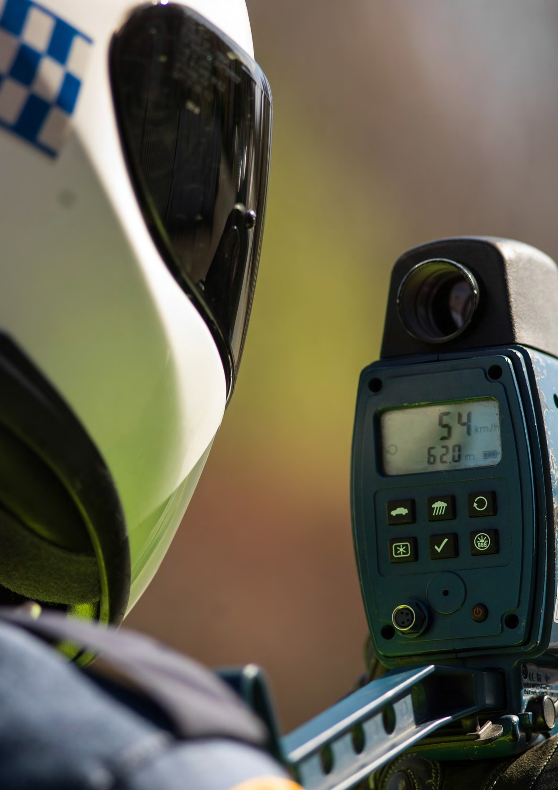

37

Community perception

“… There needs to be less emphasis on penalising minor speed breaches, and more emphasis on addressing bad driver attitudes and lack of skill…”

Research findings

Speeds at which vehicles can prevent injury are generally much

lower than the posted speed limits on the network. Establishing appropriate travelling speeds and enforcing those speeds remains one of the most effective ways to reduce death

and serious injury on any road network.

1655 fewer people killed or seriously injured on our roads
if all 110km/h roads were reduced to 100km/h; and 100km/h speed limits on minor roads were reduced to 90km/h (i.e. feeder roads, other state-controlled roads and non- state controlled roads).

What do the experts think we should prioritise?

Reduce speed limits
Establishing appropriate travelling speeds that are safe remains one the most effective ways of reducing serious casualties on the road network. Even small changes in travelling speed across the network can lead to large reductions in road trauma. This is supported

2054 fewer people killed or seriously injured on our roads if all 110km/h speed
limits were reduced to 100km/h on state-controlled roads; 100km/h speed limits on minor roads were reduced to 90km/h (i.e. feeder roads, other state-controlled roads and non-state controlled roads), and 60km/h
speed limits were reduced to 50km/h.
internationally, but much of the research has actually originated in studies on Australian roads.
Of all the interventions modelled, CASR has indicated that speed reductions of just 10km/h would have the biggest effects in reducing road trauma. The following options were considered by CASR:
    - Reducing all 110km/h speed limit to 100km/h on state-controlled roads
    - Reducing 100km/h speed limits on minor road categories to 90km/h (i.e. feeder roads, other state-controlled roads, and non-state controlled roads)
    - Reducing all 60km/h roads to 50km/h.

CASR considers that these speed limit reductions could be introduced relatively quickly early in the Strategy, and would cost less than $1 million to implement.

38

The Effects of Speed
Crash type | Speed at which likelihood of death increases dramatically
Head on collision (cars) | 70km/h
Right angle impact (cars) | 50km/h
Side impact of car into a tree or pole | 30km/h
Collision between car and pedestrian | 30km/h

What are the other options?
CASR acknowledges that the implementation of lower speed limits remains a contentious issue in the Tasmanian community. Current practice is to examine speed limits to ensure they complement road infrastructure on a case by case basis. Community engagement in changes to speed limits is critical. Speed limits need to be credible to ensure drivers comply with the limits.
Therefore, instead of the options considered above, we could look at some alternatives:
    - Implement lower speed limits on specific road corridors or in certain geographical areas rather than over the whole state.
    - Undertake an assessment of speed limits on 100km/h roads, on a case by case basis, taking into account crash risk and road features, such as shoulder and lane width.

Reducing speed across the network also represents the best option for reducing death and serious injury of our most vulnerable road users, pedestrians, cyclists and motorcyclists. While some treatments can be
developed specific to these groups, reducing speed is sufficiently broad to assist these types of road users, and the driving population as a whole. Reducing the speed limit to 40km/h in high-activity areas such as carparks and high pedestrian and cyclist areas with numerous road user types, is also considered beneficial. This would be accompanied by gateway infrastructure treatments and traffic calming measures.
Reducing speed limits is complex – we know people don’t like too much ‘chop and change’, so we also need to reduce the number of speed limit changes which occur.

What do you think we should do?

Complete the online questionnaire to provide your feedback.

4 This figure is an estimated reduction if implemented in 2017 and includes the effects of other intangibles. 5 This figure is an estimated reduction if implemented in 2017 and includes the effects of other intangibles.

39

Safe Vehicles

What did we hear from the community and stakeholders?
    - Most survey respondents indicated that vehicle safety ratings will be of major consideration when purchasing their next vehicle.
    - Most survey respondents felt that the most important safety vehicle features are electronic stability control and side and curtain airbags.
    - Many people believe that there would be benefit in introducing periodic roadworthy vehicle checks.
    - The community were divided on whether vehicle safety technology is helping or hindering drivers.

In-car technology, and the ability for a vehicle to protect occupants, has improved dramatically over past decades. Some people believe this is a positive thing, while others believe that certain safety features may result in drivers becoming ‘lazy’. However, it must be acknowledged that vehicle safety features have
proven performance when it comes to preventing serious casualties, and the sooner new vehicles (with advanced safety technologies) can be introduced into the
fleet, the sooner we will see the maximum safety benefits.

Myth: Annual vehicle inspections need to be introduced to get unsafe cars off the roads.

Not the only way….

Current crash studies have shown minimal association between crash rates and the roadworthiness of a vehicle. Without a compelling road safety benefit, it may be hard to justify a reason to impose the cost associated with periodic light vehicle inspections. In fact, evidence suggests that improving the safety features of vehicles is a more effective means of reducing road trauma.

40

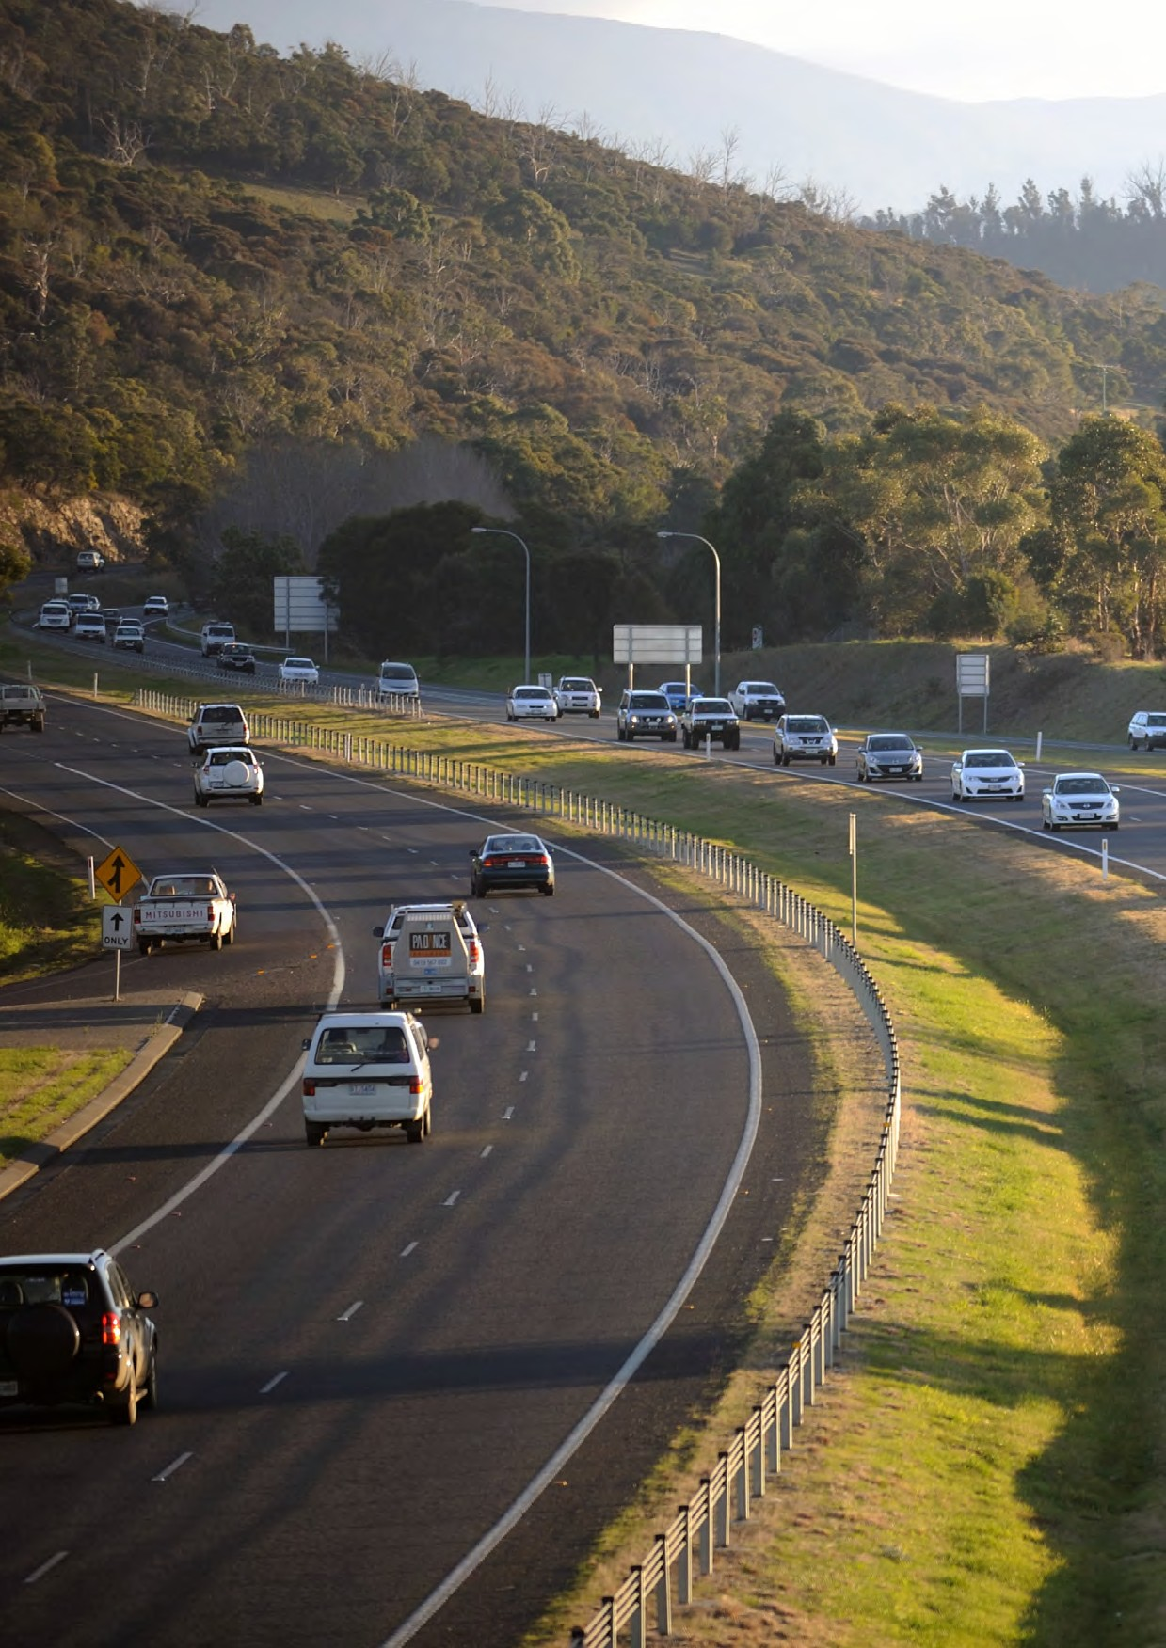

41

Community perception

“… Not everyone can afford a car which has five star safety ratings. The best safety feature is a competent driver, anyway….”

Research findings

The safety features in newer vehicles reduce the likelihood of crashes and protect people from unexpected events.

Reducing the age of Tasmania’s general vehicle fleet showed the second best potential

for serious casualty reductions. Even the smallest modelled reduction in vehicle age of five percent would produce a reduction in serious casualties comparable to reducing the speed limit on large

sections of road.

What do the experts think we should prioritise?

306 fewer people killed or seriously injured on our roads.

Focus on reducing the age of Tasmania’s vehicle fleet
Tasmania currently has an average vehicle fleet age of 12 years
– this is the oldest in the country. If the vehicle fleet age in Tasmania can be reduced in the next ten years, we are likely to see a reduction in road trauma.
There is not one obvious method to reduce the age of Tasmania’s vehicle fleet, and the process can take many years.
However, CASR considers that one of the most effective ways to speed up the process is for Government and industry to purchase new and safe vehicles for their fleets. This is the current Government policy and should be extended to industry. The effects will then flow-on to the broader community when vehicles are sold at a later date to replace older, less safe vehicles.
Promoting new vehicle safety should also remain a priority, however, the impacts on those in lower socio- economic areas must be considered. Various methods such as “cash for clunkers” schemes, introducing incentives for drivers to buy newer vehicles or mandating a maximum vehicle age are all options to consider. Drivers
at greater risk (eg. young drivers) should also be encouraged to drive newer, safer cars, as opposed to older vehicles.
Efforts to increase the amount of motorcycles in Tasmania with antilock braking systems (ABS) is considered by CASR as highly worthwhile. Mandating ABS technology on new motorcycles is also currently being considered at the federal level.
As it can take many years to improve and change over vehicles, CASR recommends that initiatives to reduce the age of the vehicle fleet should commence early in the life of the Strategy.

What are the other options?
Mandating vehicle safety features that encourage (or force) safer behaviours from drivers could also be considered, however, it must be noted that vehicle standards in Australia are largely a federal responsibility. The community may also want to consider putting more pressure on vehicle manufacturers to include more ‘standard’ safety features in new vehicles, without the additional cost.
The effectiveness of features such as intelligent speed adaptation (ISA) and broader use of alcohol interlocks was discussed by CASR. Alcohol interlocks are very effective when fitted, however, they are time consuming to operate and there is little known about how effective they might be if used by drivers who have not committed a drink driving offence.

42

ISA technology is a system that aids the driver in observing the posted speed limit. ISA technology can either provide a warning to the driver when they travel over the speed limit, provide resistance on the accelerator pedal or totally prevent the driver from speeding. Studies have shown that ISA systems can reduce serious casualty crashes by up to 30%.

Myth: We can’t prevent traffic crashes altogether.
This is true. BUT it is possible to prevent many crashes that result in death or serious injury. This is the basis of creating a Safe System.

What do you think we should do?

Complete the online questionnaire to provide your feedback.
- This figure is based on a vehicle age reduction of 5% by the year 2020, and includes the effects of other intangibles.

43

Summary of CASR Research Findings

The current level of road trauma in Tasmania is unacceptable, and our system must be improved – we all have a role to play in reducing the amount of people who lose their lives or are seriously injured on our roads.
To achieve a safer road system, a number of options have been put forward – below is a summary of the initiatives that have been recommended and discussed by CASR.
These initiatives are what the experts think we should prioritise and will be taken into account when developing the Towards Zero Strategy and action plans.

Safe Road Users
Considered by CASR |  | When should it be implemented | Serious casualty savings 2017-2026 | Cost
Key initiatives | Enhance the GLS by introducing the following novice restrictions:  - Making 18 the minimum age to obtain a driver licence  - One passenger limitation  - Curfew – prohibiting driving between 12am-6am. | Year 1 | 55 (if implemented in 2017) | $3 million
 | Continue with current level of driver behaviour education and enforcement. | Ongoing from Year 1 | Not modelled | Unknown
Other identified initiatives | Significantly increase driver education and behavioural programs. | - | Not modelled but expected to be low | Unknown
 | Increase speed camera use and enforcement levels. | - | Not modelled but studies show up to 30% reduction in crashes | Unknown
 | Lower BAC to 0.02 | - | Not modelled but studies show up to 10% reduction in crashes | Unknown but expected to be low
 | Promote protective clothing for motorcyclists | - | Not modelled but studies show can reduce hospital admissions by up to 50% | Unknown but expected to be low

44

Safe Roads and Roadsides
Considered by CASR |  | When should it be implemented | Serious casualty savings 2017-2026 | Cost
Key initiatives 7 | 2+1 configuration with centreline barrier | When feasible | 125 | $730 million
 | Audio tactile line markings | When feasible | 22 | $8 million
 | Centreline barriers | When feasible | 103 | $54 million
 | Wide centrelines (where centreline barriers are not feasible) | When feasible | 82 | $60 million
 | Sealed shoulders | When feasible | 66 | $200 million
 | Grade separation | When feasible | 36 | $2,130 million
 | Roundabouts | When feasible | 26 | $280 million
 | Eliminate right turns | When feasible | 16 | $17 million
 | Intersection plateaus | When feasible | 17 | $20 million
Other identified initiatives | Overtaking lanes with additional centreline treatments. | When feasible | Unknown but outcomes are best when centreline barrier or wide centreline are in place | Not modelled but expected to be high
 | Provide safe corridors as viable alternatives for cyclists | When feasible | Unknown | Unknown
 | Install raised platforms at dedicated pedestrian crossing facilities | When feasible | Not modelled but expected to be high if speeds are well managed | Unknown

- Costs and serious casualty savings for infrastructure treatments are based on application on all trunk roads and all initiatives being implemented in 2017. This scenario is unrealistic but it provides scenario to compare the cost and benefits of treatment options on a broad basis.

45

Safe Speeds
Considered by CASR |  | When should it be implemented | Serious casualty savings 2017-2026 | Cost
Key initiatives | Reducing all 110km/h speed limit to 100km/h.  Reducing 100km/h speed limits on minor road categories to 90km/h (i.e. feeder roads, other state-controlled roads, and no- state controlled roads).  Reducing all 60km/h roads to 50km/h. | Year 1 | 205  (if implemented in 2017) | Less than $1 million for each speed change.
Other identified initiatives | Implement lower speed limits on specific road corridors or in certain geographical areas rather than over the whole state. | - | Not modelled but any reductions in travelling speed that can be achieved are considered worthwhile. | Unknown but expected to be low
 | Reduce speed limits in high- activity areas with numerous road user types to 40km/h. | - | Not modelled but any reductions in travelling speed that can be achieved are considered worthwhile. | Unknown but expected to be low

46

Safe Vehicles
Considered by CASR |  | When should it be implemented | Serious casualty savings 2017-2026 | Cost
Key initiatives | Reducing the average age of the vehicle fleet. Options include:  - encouraging Government and industry to purchase new and safe vehicles for their fleets  - promoting new vehicle safety should also remain a priority  - “cash for clunkers” schemes  - introducing incentives for drivers to buy newer vehicles  - mandating a maximum vehicle age | Year 1 | 30 if reduction in age of 5% 59 if reduction in age of 10% 86 if reduction in age of 15%8 | It is likely that the cost of implementation could be relatively low or even neutral.
Other identified initiatives | Increase the amount of motorcycles in Tasmania with antilock braking systems (ABS) | - | Not modelled but studies show up to 37% reduction in fatal motorcycle crashes. | Unknown

How do the numbers stack up?
Over the last ten years there have been almost 3,500 deaths and serious injuries on Tasmanian roads. While our road trauma level has been decreasing due to current Strategy initiatives, changes in vehicle technology and the road system, reductions in serious casualties are starting to plateau.
If we continue with our current programs and treatments and nothing further is implemented, we could hopefully expect a small continuing decrease in serious casualties over the 10 year period to 2026. However, NO level of road trauma is acceptable – we have to determine what we can do to keep working towards zero road trauma.
In order to achieve a more significant decrease, we must determine which safety initiatives we can introduce that would have the greatest effect. If we continue with what we are doing and also introduce the new measures modelled as early as we can, we have the potential to reduce serious casualties by 2026 to little more than 150 per year.
It must be accepted that delaying new initiatives or implementing options which have a low level of effectiveness may lead to poorer outcomes. Therefore we must weigh-up the effectiveness of potential initiatives against implementation challenges and prioritise them accordingly. Ideally, we need to adopt measures that will have a significant, positive impact and will be broadly supported by the community.

- If changes implemented by 2020
47

What are the benefits to each road user group?
The following chart illustrates the benefits each road user group gains from each cornerstone of the Safe System. The more stars, the more benefits expected for the return on investment.

Road User Group
Safe Road Use
Safe Roads and Roadsides Safe Speeds
Safe Vehicles
Motorcyclists

Cyclists Pedestrians Drivers
Novice Drivers Older Drivers Rural Drivers
Children

Direct benefit to the target area

Not a direct benefit, but some significant benefit still expected. Little benefit expected

48

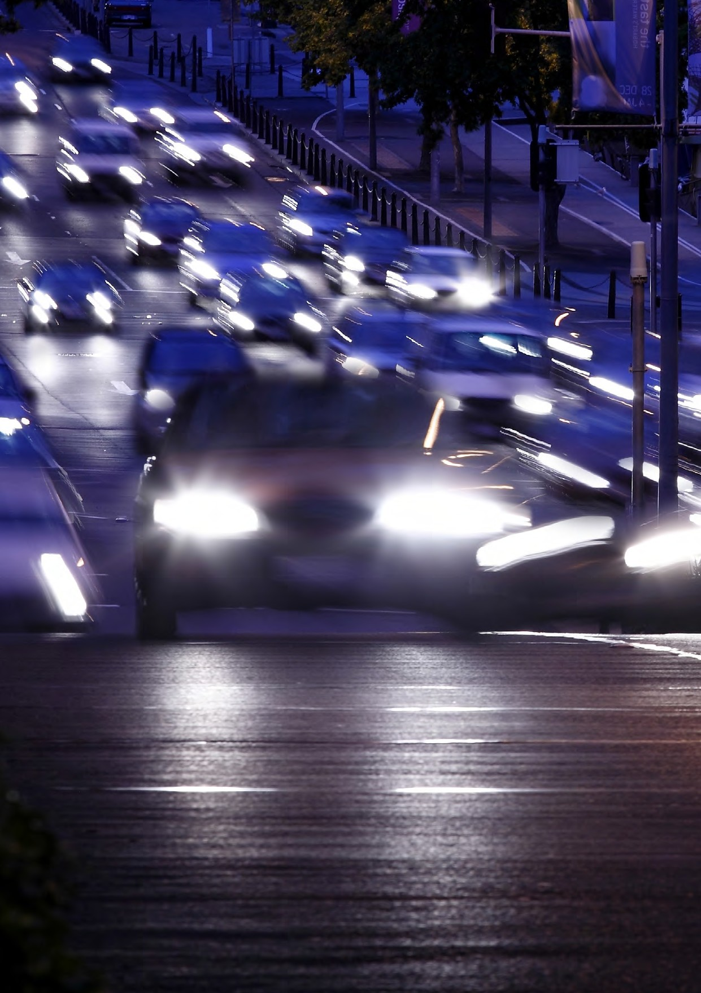

49

Next Steps

It is important to remember that this document is not the Towards Zero Strategy. We have taken comments from consultation, and the expert’s advice, and presented options for improving road safety in Tasmania. In doing this, we are seeking to stimulate discussion that considers the potential benefits of measures, their cost and the level of community support received.
Now you have seen these options, we want to know what your thoughts are. Your feedback will be crucial to the Strategy’s success.
When we receive your feedback we will analyse your comments, make improvements where necessary, and create a draft Strategy for the next ten years. We will continue to work with the community, other government agencies, stakeholders and Members of Parliament to determine the best way forward in achieving our goal.
Thank you for your contribution. Everyone has a role to play in improving road safety – it will be essential for all of us to work together to achieve our long-term vision of zero deaths and serious injuries on Tasmania’s roads.

Myth: It won’t happen to me.

Although most of us have driven for years without incident, road safety affects us all. It’s easy to become complacent, but how many people do you personally know that have been affected by a road crash? A friend, family member, someone from work, from your sports club? We are all at risk every time we use our roads.

To let us know what you think please complete the online questionnaire at www.towardszero.tas.gov.au

50

Glossary of Terms

‘2+1’ configuration | A three-lane road with the provision of alternating lanes and a flexible safety barrier located in the narrow median.*
‘2+2’ configuration | A four-lane road with a flexible safety barrier located in the narrow median.*
Audio tactile line markings | Raised or specifically textured strips typically installed on the edge line (or in some cases centreline), generating noise and vibrations through vehicles in order to alert drivers that they are leaving their lane, and encouraging them to return to their lane. ‡
Centreline barrier | A device used on multilane roads to keep opposing traffic in prescribed carriageways. ‡
Delineation | Treatments that enhance the selection of the appropriate path and speed, or position, to allow a manoeuvre to be carried out safely and efficiently, e.g. line marking, raised pavement markers, traffic cones and flaps and post-mounted reflectors. ‡
Fatality | Where a person was dead before a report was made by Tasmania Police or died up to 30 days after the crash.
Feeder road | Roads allowing safe travel between towns, major tourist destinations and industrial areas.
Flexible safety barrier | A road safety barrier system consisting of wire rope cables under high tension that are supported on posts and anchored at the ends. ‡
Grade separation | The separation of road, rail or other traffic so that crossing movements, which would otherwise conflict, are at different elevations.
Motorcycle anti- lock braking system (ABS) | System which prevents the wheels from locking up by automatically modulating the brake pressure when the rider brakes hard. By preventing the wheels from locking, the system aids riders to maintain steering control which may reduce stopping distances in certain situations.†
Plateaus | Flat top speed humps moderating speeds through the intersection, increasing the visibility of the intersection and raising awareness, specifically at intersections that are on the boundary of different speed zones, and at intersections that are dangerous or potentially dangerous.
Sealed shoulder | The sealed edge of roads outside of the travelled carriageway (the shoulder) of roads. Sometimes it is delineated by an edge line applied between the sealed shoulder and the travelled section of a carriageway. The treatment is almost invariably associated with unkerbed roads, and is often applicable to rural roads.‡
Serious casualties | Include fatalities and serious injuries.
Serious injury | Refers to a person being admitted to hospital for 24 hours or more.
Trunk road | Primary freight and passenger roads connecting Tasmania.
Wide centrelines (painted median) | Two parallel painted centrelines, often with audio tactile surfaces, which provide separation of opposing traffic.*

* Jurewicz, C Aumann, P Bradshaw, C Beesley, R Lim, A (2015), Road Geometry Study for Improved Rural Safety, Austroads Ltd, Sydney.
† OECD and ITF. (2015), Improving Safety for Motorcycle, Scooter and Moped Riders, OECD Publishing, Paris
‡ Austroads (2015) Glossary of Terms (2015 Edition), Austroads Ltd. Sydney
51

Department of State Growth Road Safety Branch
Towards Zero Strategy
GPO Box 536
Hobart TAS 7001 Australia
Phone: 03 6166 3239
Email: towardszero@stategrowth.tas.gov.au Web: www.towardszero.tas.gov.au

© State of Tasmania April 2016

